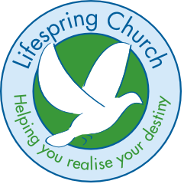
GIFT AID DECLARATION Gift Aid Number:
(For office use only)

I want Assemblies of God Incorporated to treat as Gift Aid all qualifying gifts of money I have made from the date of this declaration and in the past four years. I am a UK tax payer and I understand that if I pay less Income Tax and / or Capital Gain Tax than the amount of Gift Aid claimed on all my donations in that tax year, it is my responsibility to pay any difference.
Cheques to be made payable to: Lifespring Church – thank you!

Name: ________________________________________________________________________________
Address: _______________________________________________________________________________
_______________________________________________________________________________________
_______________________________________________________________________________________

Signature _____________________________________ Date: _______________________

